On-Line Membership Payment Instructions, Interac-e and RBC to RBC
- By on-line banking interact-e, this is probably the most convenient for members who are familiar with on-line banking. The Club Spartan is now registered for Interac Auto Deposits to receive Interact-e transfer payments. RBC example is as follows, other Financial Institutions provide similar entries as basic process is dictated by Interac. Snap shots for Scotia Bank are provided as further detailed instructions.
- Members can also Pay their membership if they bank with RBC by direct transfer to Club Spartan Account;
RBC Club Spartan Account: Branch: 361, Account number; 1008333
- On Initiation of Interact-e transfer payment (Typical RBC)
Step 1 Pay with Bank Account
- From account: (Your Account)
- To: Interac-e Transfer
- Enter Amount: $20.00
- When: Date: (Date of initiation)
- Frequency: Once
- SUBMIT
Step 2 Send Interac-e Transfer
- Recipients name, email address
- Name: Club Spartans
- Add recipient to payee List
- Contact Method:
- Email Address: club.spartans@yahoo.com
- CONTINUE
Step 3 Confirm Details of Interac e-transfer
- To: Club Spartans
- Contact Method: (Email) club.spartans@yahoo.com,
- Security Question: (See Note 1)
- Security Answer: (See Note 1)
- Will show:
- Amount: $20
- Service Fee: Free
- From Account: member bank account (visible only to member)
- Message: 2 year membership dues 2020-2021, (Member name)
Note 1: The Club is registered to receive interact-e transfers under club.spartans@yahoo.com, automatically and the Security question and answer is not applicable.

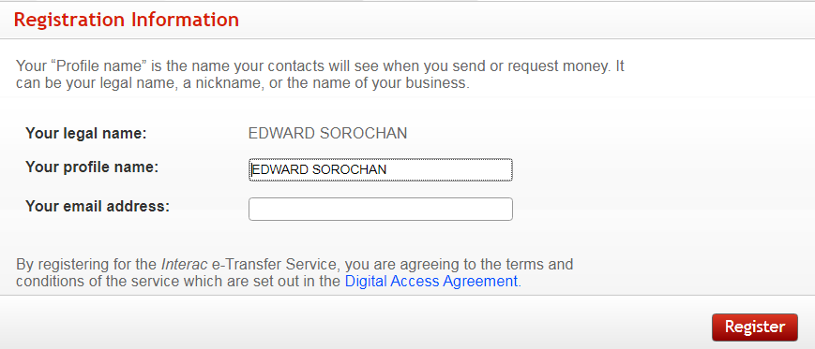
Your legal Name
Profile and Email

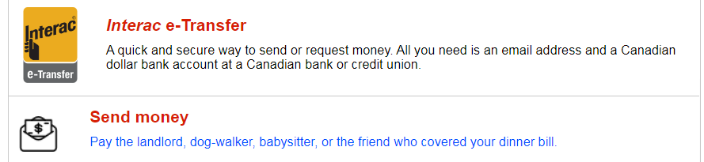
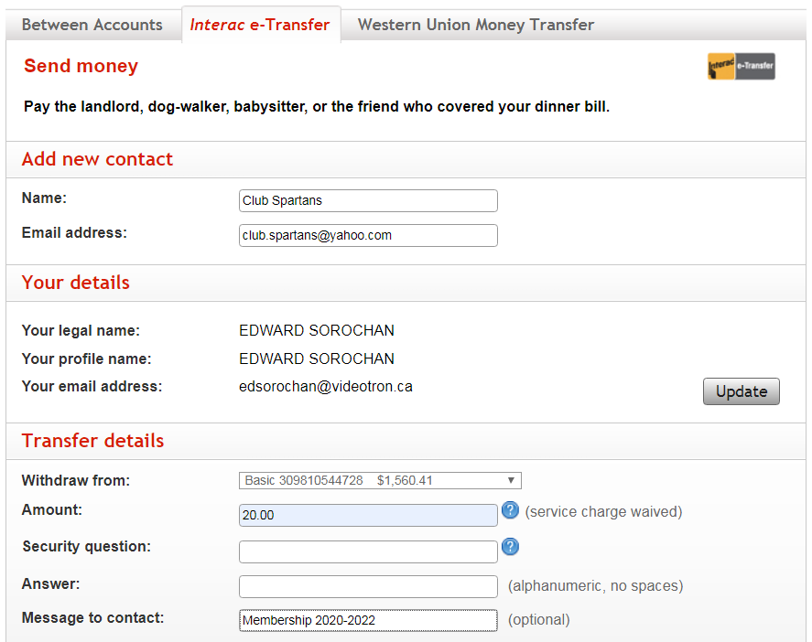
Your legal name, profile and Email
XXXXX Your Acct # and $ Balance shown
Note: Security Question and Answer is not applicable because Club Spartans RBC account is registered for Auto deposit.
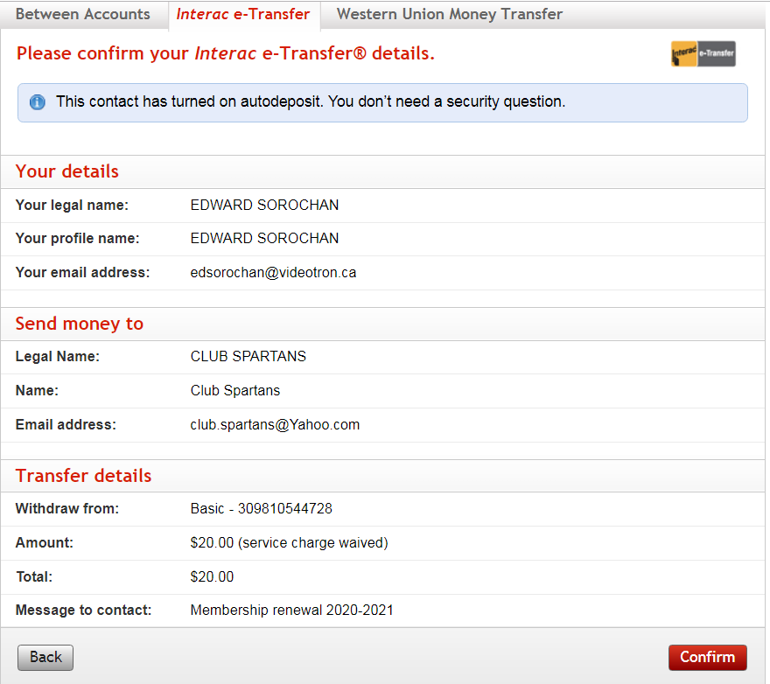
Your legal Name
Profile and Email
XXXXX Your Account Number

